Eventi
Use Case Specification

Submitted to:

Asst. Prof. Ma. Rowena C. Solamo
Faculty Member
Department of Computer Science
College of Engineering
University of the Philippines, Diliman

Submitted by:
Dimaano, Aaron Diego I.
Lopez, Matthew S.
Torres, Jacob Angelo V.

In partial fulfillment of academic requirements
for the course
CS 191 Software Engineering I
of the
1st Semester, AY 2015-2016
Unique Reference:
The documents are stored in https://github.com/Tom-2013-06417/CS191-192_Event_Sharing/tree/master/02-Requirements%20Engineering.
Link to this document:

Document Purpose:
The purpose of this document is to exhaust the step-by-step process of the Use Cases in every scenario possible.

Target Audience:
To our project client and adviser, our fellow 191 classmates, and our future selves when they need to refer back to this document.

Revision Control:

Revision Date | Person Responsible | Version  Number | Modification
09/18/15 | Dimaano, Diego  Lopez, Matthew  Torres, Jacob | 1.0 | Initial Document

Use-Case Name: Follow organization account

Description: This is an added functionality for registered users so that they keep updated regarding the events held by a certain organization. The events held by followed organizations shall appear on the registered user’s events board. Of course, if there’s a feature to follow an organization, there’s also the choice of unfollowing the organization, so that they no longer appear on the registered user’s events board.

Preconditions: The Registered User is logged in.

Flow of Events:

Scenario Name | Description
Scenario 1 (Basic Flow)  Follow an organization | - Registered User opens an Organization's profile page  (view Use Case 2.1)  - Registered User clicks the follow button on the Organization's profile page

Activity Diagram of the Flow of Events:

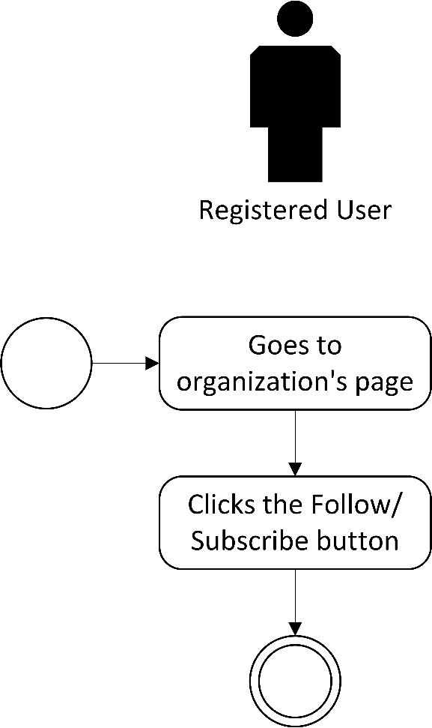

Post-conditions: Successful: The Registered User has followed or subscribed to the organization account.
Failed: The subscription did not push through.

Special Requirements: NONE

